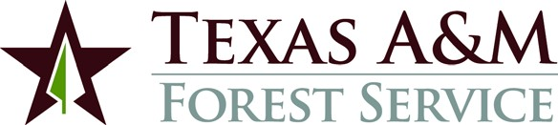

MEETING NOTICE

Texas Intrastate Fire Mutual Aid System
Grant Program
(TIFMAS)

Texas A&M Forest Service will conduct a funding meeting to approve
grants under the Texas Intrastate Fire Mutual Aid System Grant Program (TIFMAS). The meeting will be Tuesday, October 17, 2017 commencing at 9:30 a.m. in Room 1105 B of the TFS State HQ Building in College Station, Texas.

TFS State HQ Building
200 Technology Way
College Station, TX 77845-3424

The meeting is open to the public.

